Biology Assignment – Friday, December 15th, 2017
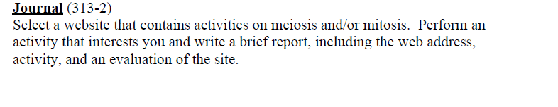
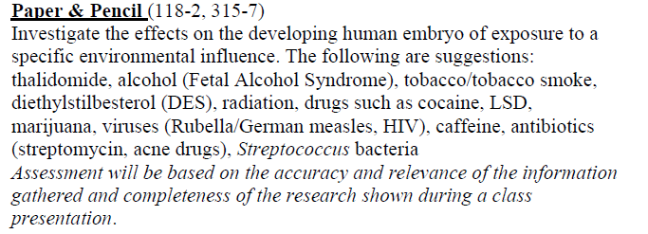
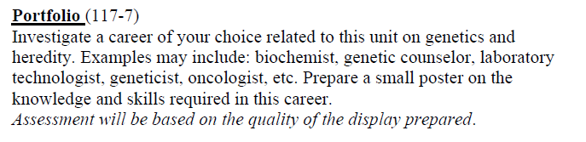
(You will not create a small poster, simply write a paragraph or two on the career of your choice).
