GMF Research Activity
Part 1
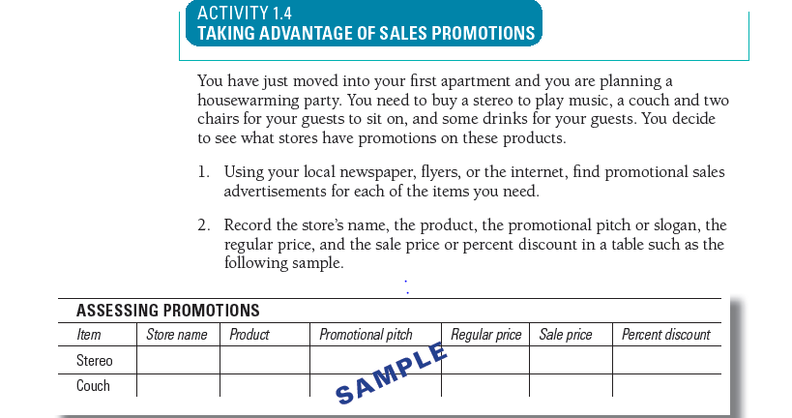
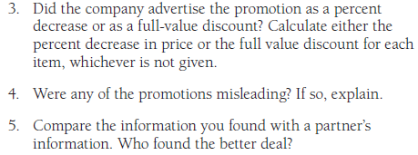

Part 2
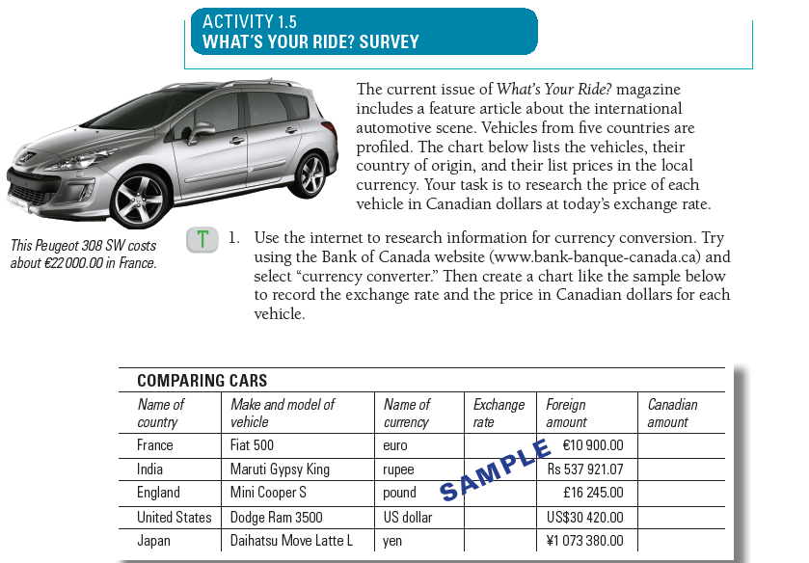
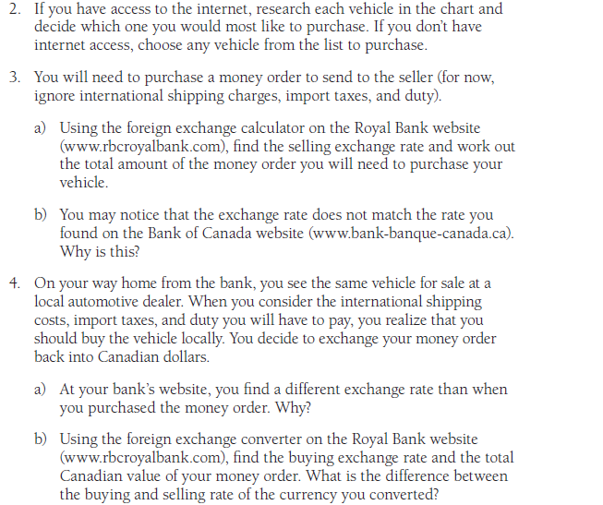

Part 3
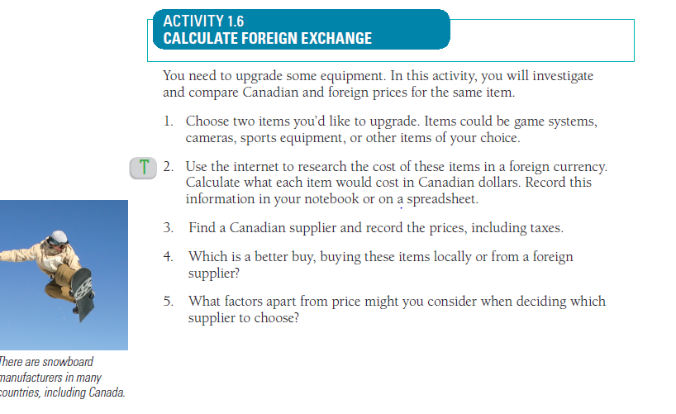
Part 4
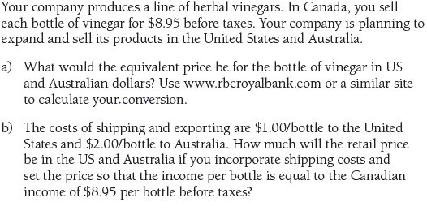

Part 5
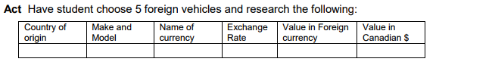
Part 6
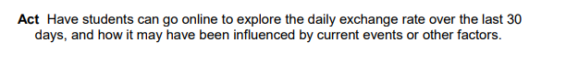
Part 7
Try the Following Games
Math is Fun site http://www.mathsisfun.com Towers of Hanoi http://www.mathsisfun.com/games/towerofhanoi.html Tic-Tac-Toe http://www.mathsisfun.com/games/tic-tac-toe.html Dots and Boxes Game http://www.mathsisfun.com/games/dots-and-boxes.html Four in a Line http://www.mathsisfun.com/games/connect4.html

